**Asssignment 23.1**

Problem Statement

Create a database named 'custom'. Create a table named temperature_data inside custom having below fields: 1. date (mm-ddyyyy) format 2. zip code 3. temperature The table will be loaded from comma-delimited file. Load the dataset.txt (which is ',' delimited) in the table.

Commands used for creating database custom and table temperature_data within it.

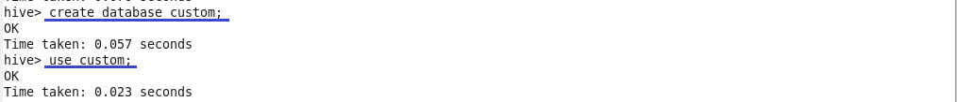

Displaying the dataset loaded into table

